**Rev _ 1.Modelo RF5_Indeg Apoio Controlo Diques X All var**.

***Instrucciones modelo***: **test size = 0.2 ; rd_state = 3**

***Variables indep select to fit***:

variables = [    'id', 'Indeg_RedeConfianc', 'PC1_Distance_Pro',

'Degree_RedeTotFamil',   ,'9_VarExp_Atri_IndMelhorTecnDiqCint',

    'OutDeg_IntimAmigos_', 'OutDeg_RedeRisk_Cen', 'OutDeg_RedeConfianc']

***Model performance (scores):***

Mean Squared Error: 1

R^2 Score: 0.5058 (In Excel: R2 = 0.5326; y = 0.517 X + 1.307 )

**Model tot:**

Mean Squared Error (MSE): 0.5116

Root Mean Squared Error (RMSE): 0.7153

Mean Absolute Error (MAE): 0.4341

R^2 Score: 0.8443

Pearson Correlation: 0.9297

***Interactions***:

| **Interacción** | **Importancia** | **Dirección** |
| --- | --- | --- |
| 0 | (9_VarExp_Atri_IndMelhorTecnDiqCint, OutDeg_Re... | 0.725648 | 0.023790 |
| 1 | (9_VarExp_Atri_IndMelhorTecnDiqCint, OutDeg_In... | 0.699958 | 0.025463 |
| 2 | (Indeg_RedeConfianc, OutDeg_RedeConfianc) | 0.640858 | 0.053254 |
| 3 | (OutDeg_RedeRisk_Cen, OutDeg_RedeConfianc) | 0.633710 | 0.046511 |
| 4 | (PC1_Distance_Pro, OutDeg_RedeConfianc) | 0.614130 | -0.015400 |
| 5 | (OutDeg_IntimAmigos_, OutDeg_RedeRisk_Cen) | 0.599834 | 0.089870 |
| 6 | (PC1_Distance_Pro, OutDeg_IntimAmigos_) | 0.580993 | -0.015429 |
| 7 | (OutDeg_IntimAmigos_, OutDeg_RedeConfianc) | 0.574445 | 0.083171 |
| 8 | (Degree_RedeTotFamil, OutDeg_IntimAmigos_) | 0.570716 | 0.043378 |
| 9 | (Degree_RedeTotFamil, OutDeg_RedeConfianc) | 0.568463 | 0.037944 |

***Key results****:*

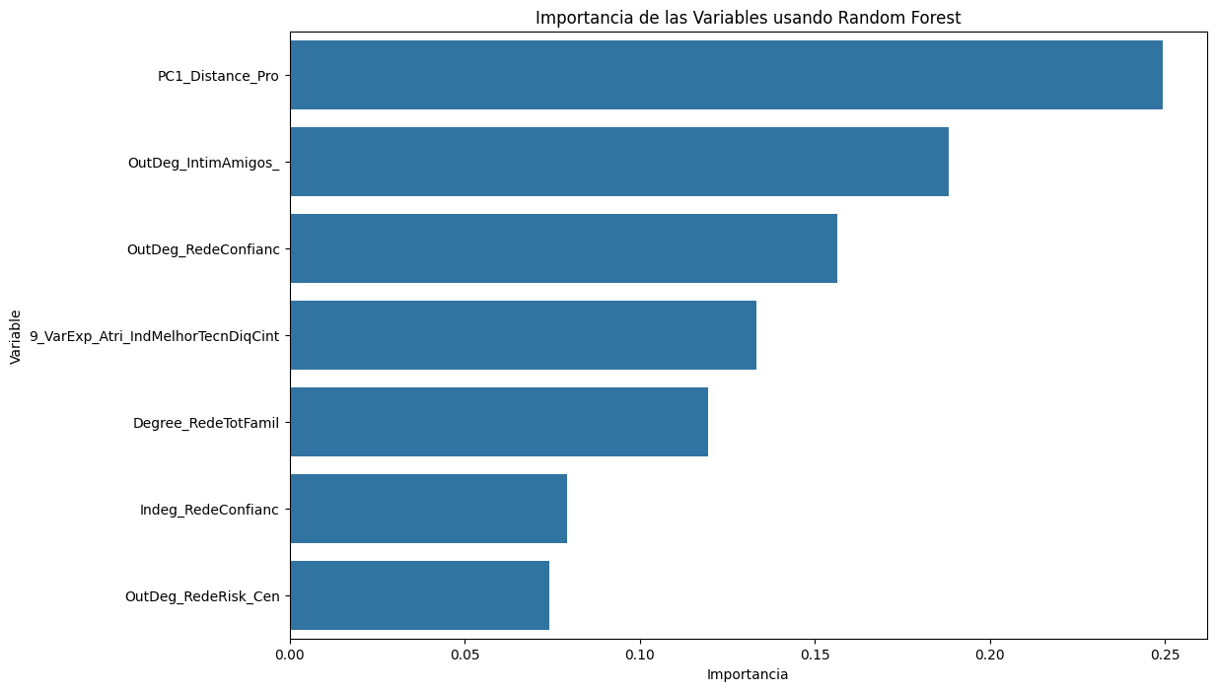

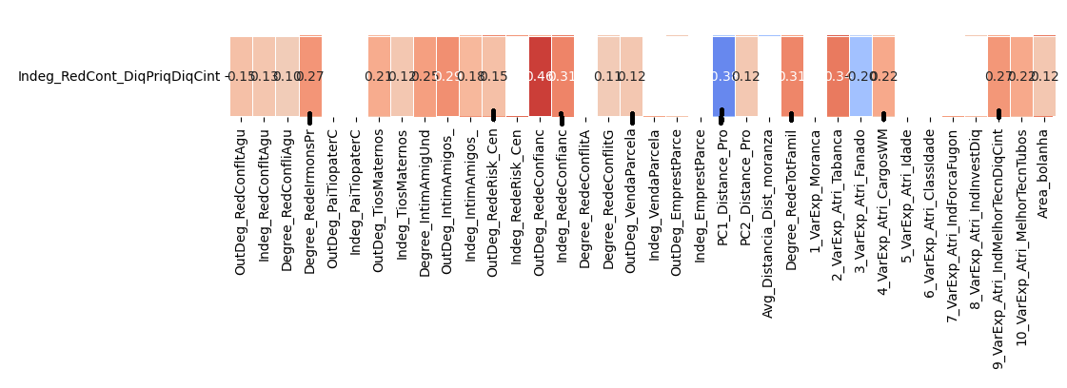

**VER INTEGRANDO VARIAVEL Melhor técnico tubos**

**2.Modelo RF5_Outdeg Apoio Controlo Diques X All var**.

***Instrucciones modelo***: **test size = 0.2 ; rd_state = 42**

***Variables indep select to fit***:

variables = ['id', “Indeg_RedeConfianc','Degree_RedeTotFamil', '9_VarExp_Atri_IndMelhorTecnDiqCint', '10_VarExp_Atri_MelhorTecnTubos'

'Area_bolanha', Indeg_IntimAmigUnd' ,'OutDeg_RedeRisk_Cen']

***Model performance (scores):***

Mean Squared Error: 1.6538

R^2 Score: 0.8931 (In Excel: R2 = 0.9305 ; y = 0.7644 X + 0.2611 )

**Model tot:**

Mean Squared Error (MSE): 0.6977

Root Mean Squared Error (RMSE): 0.8353

Mean Absolute Error (MAE): 0.4496

R^2 Score: 0.9449

Pearson Correlation: 0.9788

***Interactions***:

| **Interacción** | **Importancia** | **Dirección** |
| --- | --- | --- |
| 0 | (Indeg_RedeConfianc, 8_VarExp_Atri_IndInvestDiq) | 3.761719 | 1.030689 |
| 1 | (Indeg_RedeConfianc, 7_VarExp_Atri_IndForcaFugon) | 3.760980 | 1.035911 |
| 2 | (Indeg_RedeConfianc, PC1_Distance_Pro) | 3.756387 | 1.040981 |
| 3 | (Indeg_RedeConfianc, Area_bolanha) | 3.736113 | 1.031046 |
| 4 | (Indeg_RedeConfianc, Degree_RedeTotFamil) | 3.735462 | 1.018453 |
| 5 | (Indeg_RedeConfianc, OutDeg_RedeRisk_Cen) | 3.720480 | 1.022732 |
| 6 | (Indeg_RedeConfianc, 10_VarExp_Atri_MelhorTecn... | 3.701941 | 1.002835 |
| 7 | (Indeg_IntimAmigos_, Indeg_RedeConfianc) | 3.672070 | 0.003478 |
| 8 | (Indeg_RedeConfianc, 9_VarExp_Atri_IndMelhorTe... | 3.546245 | 0.960235 |
| 9 | (9_VarExp_Atri_IndMelhorTecnDiqCint, 10_VarExp... | 1.127547 | 0.108298 |

***Key results****:*

